Batch:E-2 Roll No.: 16010123325

Experiment No. 01

TITLE: Design the static web pages with the help of HTML5

AIM: To create static Web Pages using HTML5.
______________________________________________________________________
Expected Outcome of Experiment: Design static web pages using various HTML tags.
_______________________________________________________________
Books/ Journals/ Websites referred:

- .

_____________________________________________________________________

The students are required to design Web Application using various technologies. A group of 2-3 students will select a topic and will design a web application. Various concepts such as static page, dynamic page, connection with a backend database are essential part of the application.

Students will be required to mention overall description of the problem (website facilities) to be provided by their application.

Problem Statement:

< Explain in words what facilities / functionalities your application is expected to support>

The application supports:
- User Registration: Secure form to collect and validate user details.
- Data Display: Organized tables for information like listings or user data.
- Search and Input Forms: To query or submit information.
- Navigation: Intuitive layout for seamless page access.
- Visual Design: Styled content with headings, images, and text for readability.
- Dynamic Interactions: Buttons for actions like submission and navigation

Description of the application implemented with output:

< Add screen shots of the pages here>



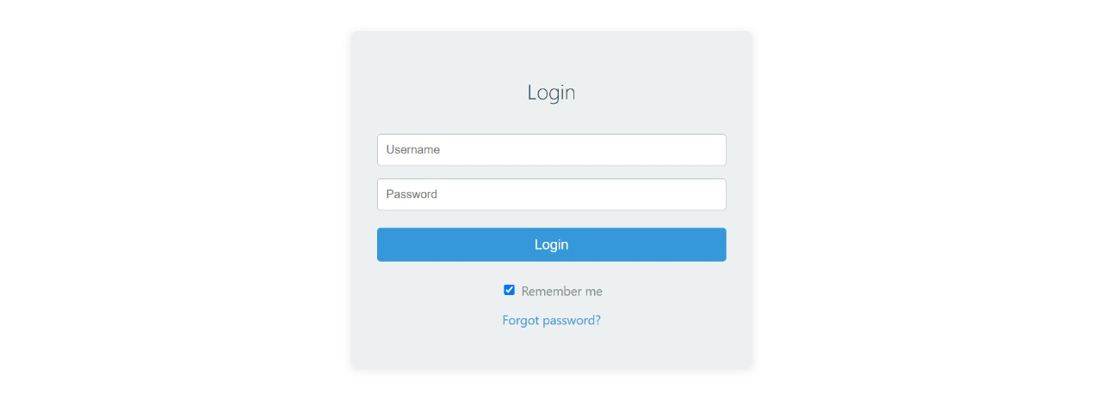

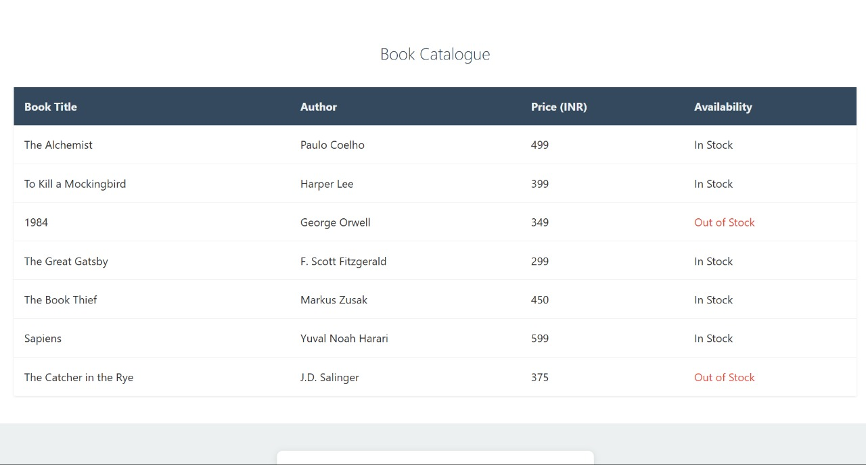

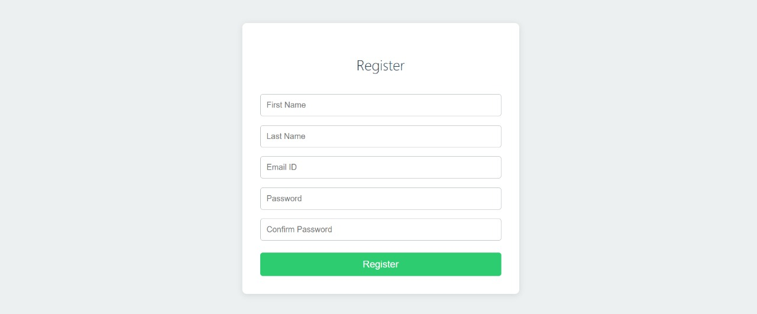

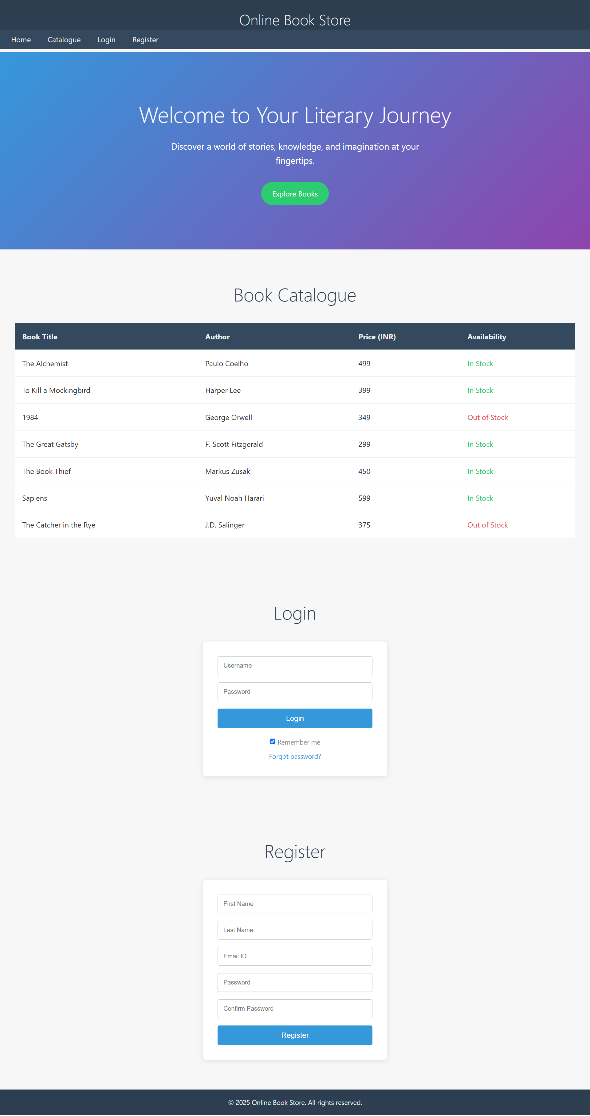

Post Lab Objective with Ans (Min 5):
HTML tags Used :

<Tabulate all the HTML tags you have used to create the page, mentioning the usage>

Here is a tabulated summary of the HTML tags used in your pages, along with their usage:

HTML Tag | Usage
HTML Tag | Usage Description
<!DOCTYPE html> | Defines the document type and version of HTML.
<html> | Root element of an HTML document.
<head> | Contains meta-information about the document.
<meta> | Specifies metadata such as character set and viewport settings.
<title> | Sets the title of the document, shown in the browser's title bar or tab.
<style> | Contains CSS styles for the document.
<body> | Contains the content of the HTML document.
<header> | Defines a header section for the document or a section.
<h1> | Defines the main heading of the document.
<nav> | Defines a navigation section with links.
<a> | Defines a hyperlink.
<main> | Specifies the main content of the document.
<section> | Defines a section in the document.
<h2> | Defines a subheading.
<p> | Defines a paragraph.
<div> | Defines a division or section in the document.
<table> | Defines a table.
<thead> | Groups the header content in a table.
<tr> | Defines a row in a table.
<th> | Defines a header cell in a table.
<tbody> | Groups the body content in a table.
<td> | Defines a cell in a table.

Code:

<!DOCTYPE html>
<html lang="en">
<head>
<meta charset="UTF-8">
<meta name="viewport" content="width=device-width, initial-scale=1.0">
<title>Online Book Store</title>
<style>
* {
margin: 0;
padding: 0;
box-sizing: border-box;
}
html {
scroll-behavior: smooth;
}
body {
font-family: 'Segoe UI', Tahoma, Geneva, Verdana, sans-serif;
line-height: 1.6;
color: #333;
background-color: #f7f7f7;
}
header {
background: #2c3e50;
color: #ecf0f1;
padding: 1rem;
position: fixed;
width: 100%;
top: 0;
z-index: 1000;
}
nav {
background: #34495e;
padding: 0.5rem;
position: fixed;
width: 100%;
top: 4rem;
z-index: 1000;
}
nav a {
color: #ecf0f1;
text-decoration: none;
padding: 0.5rem 1rem;
transition: color 0.3s ease;
}
nav a:hover {
color: #3498db;
}
main {
padding-top: 7rem;
}
section {
padding: 4rem 2rem;
}
h1, h2 {
text-align: center;
font-weight: 300;
}
h1 {
font-size: 2rem;
}
h2 {
font-size: 2.5rem;
margin-bottom: 2rem;
color: #2c3e50;
}
#home {
background: linear-gradient(135deg, #3498db, #8e44ad);
color: #fff;
text-align: center;
padding: 6rem 2rem;
}
#home h2 {
font-size: 3rem;
margin-bottom: 1rem;
color: #fff;
animation: fadeInDown 1s ease-out;
}
#home p {
font-size: 1.2rem;
max-width: 600px;
margin: 0 auto 2rem;
animation: fadeInUp 1s ease-out 0.5s both;
}
.cta-button {
display: inline-block;
padding: 0.75rem 1.5rem;
background-color: #2ecc71;
color: #fff;
text-decoration: none;
border-radius: 30px;
font-size: 1rem;
transition: all 0.3s ease;
animation: fadeInUp 1s ease-out 1s both;
}
.cta-button:hover {
background-color: #27ae60;
transform: translateY(-3px);
box-shadow: 0 4px 10px rgba(0,0,0,0.2);
}
table {
width: 100%;
border-collapse: collapse;
background: #fff;
box-shadow: 0 1px 3px rgba(0,0,0,0.1);
}
th, td {
padding: 1rem;
text-align: left;
border-bottom: 1px solid #ecf0f1;
}
thead {
background: #34495e;
color: #ecf0f1;
}
tbody tr:hover {
background: #f8f9fa;
}
form {
max-width: 400px;
margin: 0 auto;
background: #fff;
padding: 2rem;
border-radius: 8px;
box-shadow: 0 2px 10px rgba(0,0,0,0.1);
}
input[type="text"],
input[type="email"],
input[type="password"] {
width: 100%;
padding: 0.75rem;
margin-bottom: 1rem;
border: 1px solid #bdc3c7;
border-radius: 4px;
}
button[type="submit"] {
width: 100%;
padding: 0.75rem;
background: #3498db;
color: #fff;
border: none;
border-radius: 4px;
cursor: pointer;
font-size: 1rem;
transition: background 0.3s ease;
}
button[type="submit"]:hover {
background: #2980b9;
}
footer {
background: #2c3e50;
color: #ecf0f1;
text-align: center;
padding: 1rem;
font-size: 0.9rem;
}
</style>
</head>
<body>
<header>
<h1>Online Book Store</h1>
</header>
<nav>
<a href="#home">Home</a>
<a href="#catalogue">Catalogue</a>
<a href="#login">Login</a>
<a href="#register">Register</a>
</nav>
<main>
<section id="home">
<h2>Welcome to Your Literary Journey</h2>
<p>Discover a world of stories, knowledge, and imagination at your fingertips.</p>
<a href="#catalogue" class="cta-button">Explore Books</a>
</section>
<section id="catalogue">
<h2>Book Catalogue</h2>
<div style="overflow-x: auto;">
<table>
<thead>
<tr>
<th>Book Title</th>
<th>Author</th>
<th>Price (INR)</th>
<th>Availability</th>
</tr>
</thead>
<tbody>
<tr>
<td>The Alchemist</td>
<td>Paulo Coelho</td>
<td>499</td>
<td style="color: #2ecc71;">In Stock</td>
</tr>
<tr>
<td>To Kill a Mockingbird</td>
<td>Harper Lee</td>
<td>399</td>
<td style="color: #2ecc71;">In Stock</td>
</tr>
<tr>
<td>1984</td>
<td>George Orwell</td>
<td>349</td>
<td style="color: #e74c3c;">Out of Stock</td>
</tr>
<tr>
<td>The Great Gatsby</td>
<td>F. Scott Fitzgerald</td>
<td>299</td>
<td style="color: #2ecc71;">In Stock</td>
</tr>
<tr>
<td>The Book Thief</td>
<td>Markus Zusak</td>
<td>450</td>
<td style="color: #2ecc71;">In Stock</td>
</tr>
<tr>
<td>Sapiens</td>
<td>Yuval Noah Harari</td>
<td>599</td>
<td style="color: #2ecc71;">In Stock</td>
</tr>
<tr>
<td>The Catcher in the Rye</td>
<td>J.D. Salinger</td>
<td>375</td>
<td style="color: #e74c3c;">Out of Stock</td>
</tr>
</tbody>
</table>
</div>
</section>
<section id="login">
<h2>Login</h2>
<form action="#" method="post">
<input type="text" name="username" placeholder="Username" required>
<input type="password" name="password" placeholder="Password" required>
<button type="submit">Login</button>
<div style="margin-top: 1rem; text-align: center;">
<label style="font-size: 0.9rem; color: #7f8c8d;">
<input type="checkbox" name="remember" checked> Remember me
</label>
<p style="margin-top: 0.5rem; font-size: 0.9rem;">
<a href="#" style="color: #3498db; text-decoration: none;">Forgot password?</a>
</p>
</div>
</form>
</section>
<section id="register">
<h2>Register</h2>
<form action="#" method="post">
<input type="text" name="first_name" placeholder="First Name" required>
<input type="text" name="last_name" placeholder="Last Name" required>
<input type="email" name="email" placeholder="Email ID" required>
<input type="password" name="password" placeholder="Password" required>
<input type="password" name="confirm_password" placeholder="Confirm Password" required>
<button type="submit">Register</button>
</form>
</section>
</main>
<footer>
<p>&copy; 2025 Online Book Store. All rights reserved.</p>
</footer>
</body>
</html>

